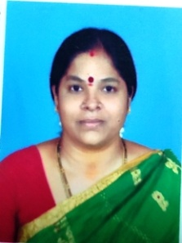

**STAFF PROFILE**

|  |  |  |
| --- | --- | --- |
| Name | : | **Mrs.S.BHANUMATHY** |
| Designation | : | **Dietician** |
| Qualification | : | **B.Sc.,M.Sc.,(Nutrition),PGDTM** |
| Experience | : | **27 Years** |
| Educational Institute |  | **B.Sc. – The Gandhigram Rural Institute 1991** |
|  | **M.Sc. - Avinashilingam Institute for Home Science and Higher Education for Women (1991-1993)** |